Week 1
Session 5 - 1
Code :
class Solution {
public int[] sortedSquares(int[] nums) {

int[] result = new int[nums.length];

for (int i = 0; i < nums.length; i++) {
result[i] = nums[i] * nums[i];
}

Arrays.sort(result);

return result;
}
}

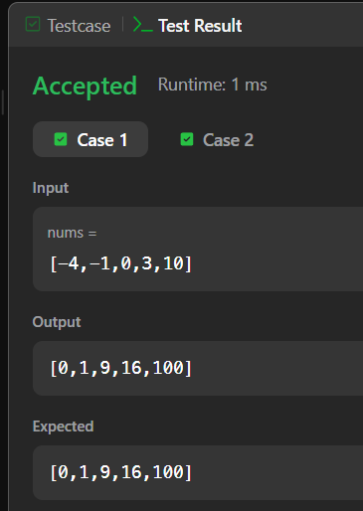

Session 5 -2
Code :

class Solution {
public int pivotIndex(int[] nums) {

int total = 0;

for (int num : nums) {
total += num;
}

int leftSum = 0;

for (int i = 0; i < nums.length; i++) {

int rightSum = total - leftSum - nums[i];

if (leftSum == rightSum) {
return i;
}

leftSum += nums[i];
}

return -1;
}
}

